**Lab 7**

**Operational Amplifiers – Basic Characteristics and Applications**

**Objective**

The objective of this lab experiment is to learn how to use the operational amplifier (op-amp). In this experiment some of the basic characteristics of the op-amp would be examined and then some of its applications like the Inverting amplifier, non-inverting amplifier will be experimented.

**Theory Overview**

The Operational Amplifier (Op Amp) is an extremely useful device, as we will see in this lab. With the addition of a few external components, an extraordinary variety of functions can be implemented. The Op Amp is an active element that needs to be supplied with power to operate. A common way to supply this power is shown in Figure 1(a). Two power supply voltages are used, with equal values denoted by Vcc and VDD (or ±VCC) (often in the range of 5 V to15 V). The common node between the supplies is the ground node. The op amp’s output voltage is taken between the output terminal and the ground node. The remaining two terminals are the input of the op amp. An interesting property of the op-amp is that the output voltage is only a function of the difference of the two input Terminals. Figure 1(b) shows the top view of widely used OpAmp type known as the 741. It comes in a package, with metal pins.

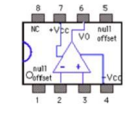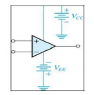

**Figure 1 (a) and (b)**

The most basic function of the op amp is the voltage amplification. However, the output voltage of a real op amp is limited to the range between certain limits that depend on the internal design of the op amp. As shown in Figure 2, when the output voltage tries to exceed these limits, clipping occurs.

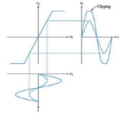

**Figure 2**

**Equipment:**

1. Digital multimeter

2. Variable DC power supply

3. Oscilloscope

4. Function generator

5. Protoboard

**Components**

1. 100kΩ

2. 10kΩ

3. 741 op-amp

**Procedure**

**Inverting amplifier**

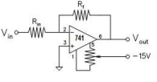

**Figure 3**

1. Wire the circuit shown with Rf = 100 kΩ and Rin= 10kΩ (gain 10); Set DMM to an appropriate scale.

2. For five or more values of Vin, in the range ±0.7V calculate the value of Vout using the following formula for voltage gain of Inverting amplifier and write them in Table 1:

*Av=Vout /Vin= -Rf / Rin.*

3. Measure the value of Vout for each value of Vin as mentioned above, using a DC voltmeter and write the results in Table 1. Find the % age error.

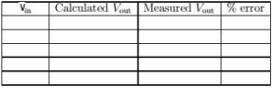

**Table 1**

4. Set the Function generator at a frequency of 1 kHz and apply as input Vin to the inverting amplifier. Use the two channels of the scope to monitor the inverting input Vin of the op-amp and the output Vout. Slowly increase the amplitude of the input signal, starting near zero. Observe the phase difference between the input and output. Keeping the amplitude of the input low and constant, vary its frequency. Observe the reduction in output amplitude as frequency increases.

**Non – Inverting Amplifier:**

1. Set up the non-inverting amplifier circuit of Figure 4 with R1 = 10 k. With a 1 kHz sinusoidal input having different amplitudes, calculate the output with R2 = 100k and with R2= 10k using the

formula and write the results in front of each input in Table 2:

*Av =Vout/Vin=1+R2/R1*

2. Measure the output with an oscilloscope and write them in front of each input in the table. Find the % age error.

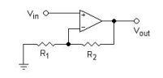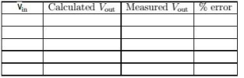**Table 2**

